How to Access Your Child’s Teacher Page

1. Note that the new website is [www.rcboe.org/davidson](http://www.rcboe.org/davidson). Then click on Staff & Departments.

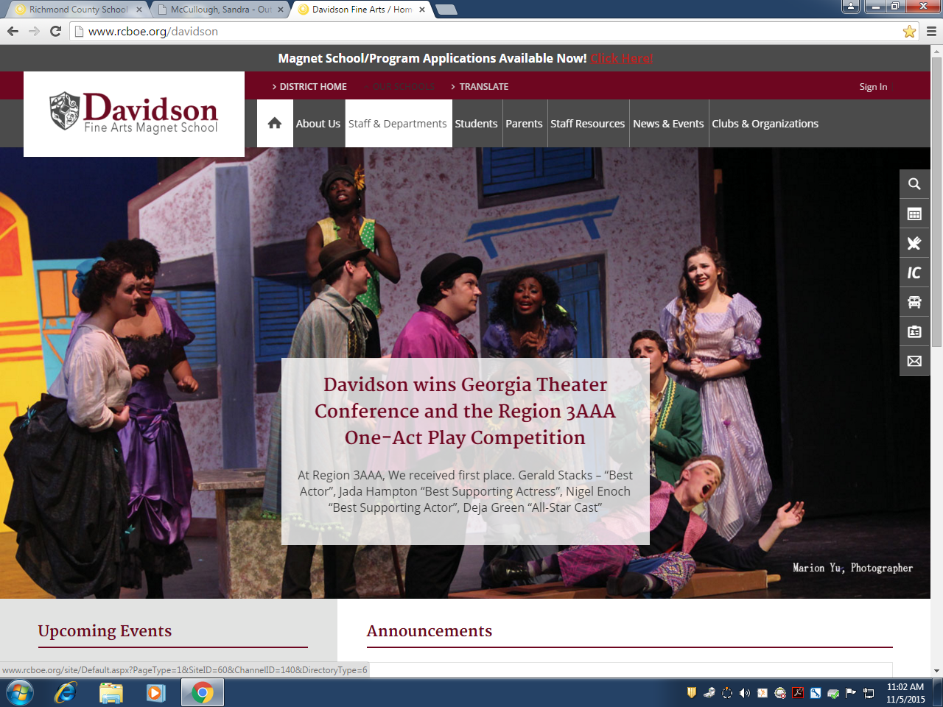 2. Here you will find a list of the teachers. Click on the teacher’s class you want to view.

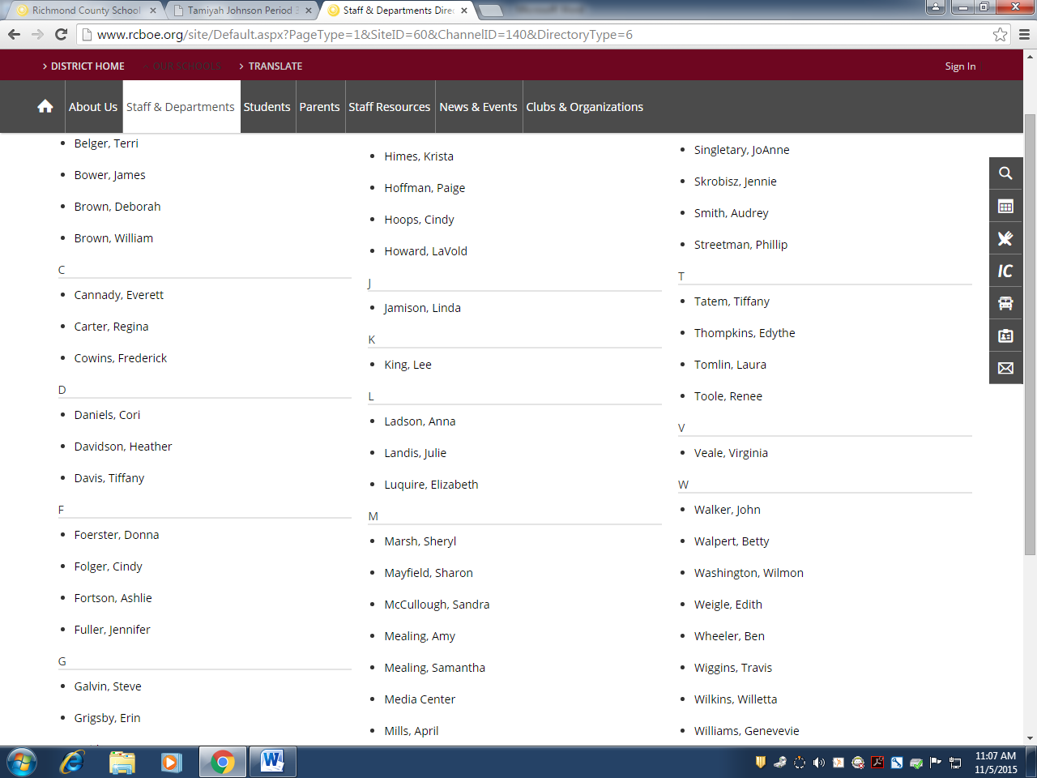 3. This is what you should see next.

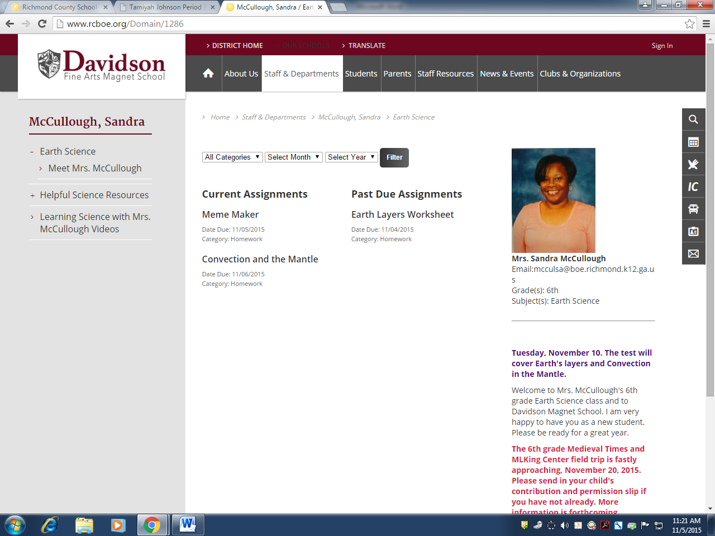 4. Click on the “Earth Science” link on the left side of the page to view the homework assignment.

 5. Click on each assignment to see a description.

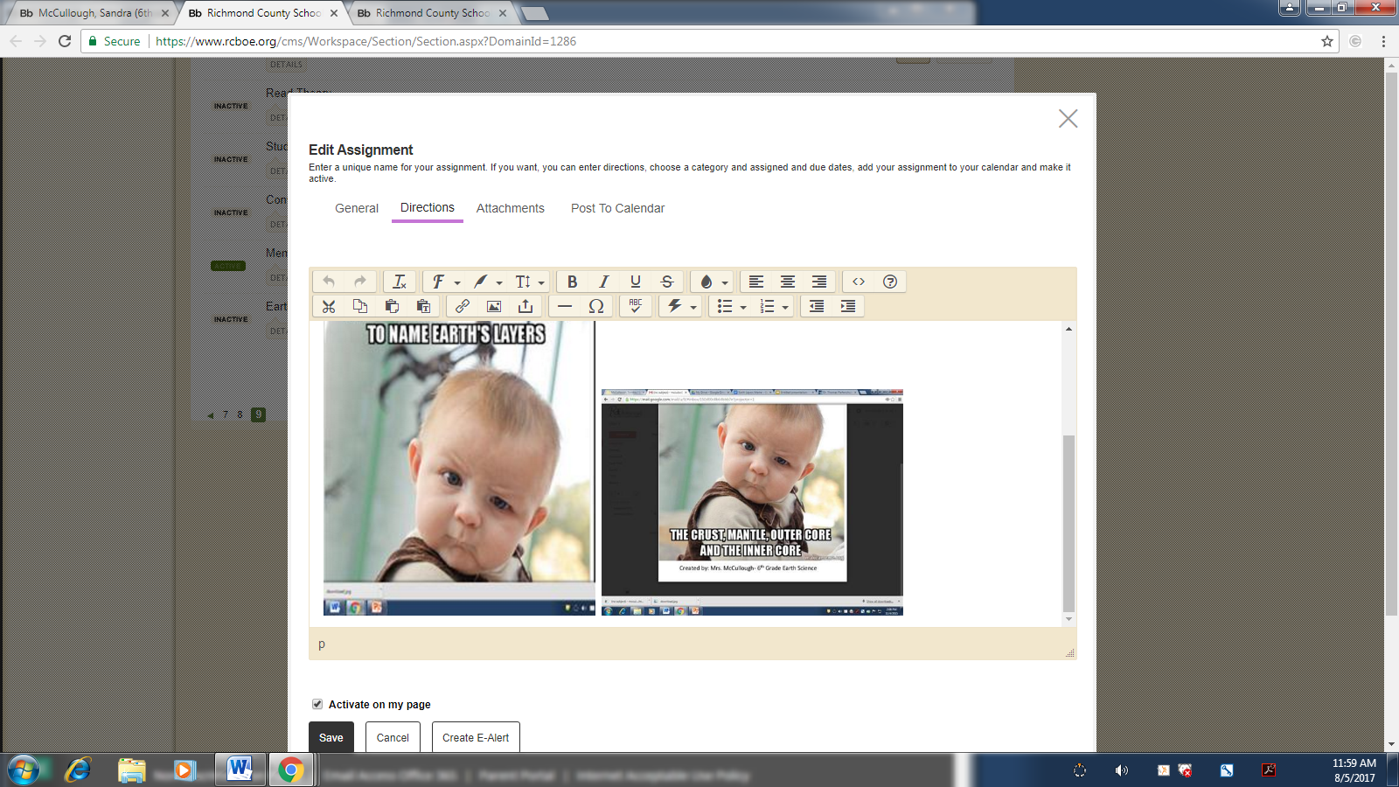 6. When you click on the name of the assignment, you will see the full description of the assignment.